We are gonna use AAPL stock for this prediction  
  
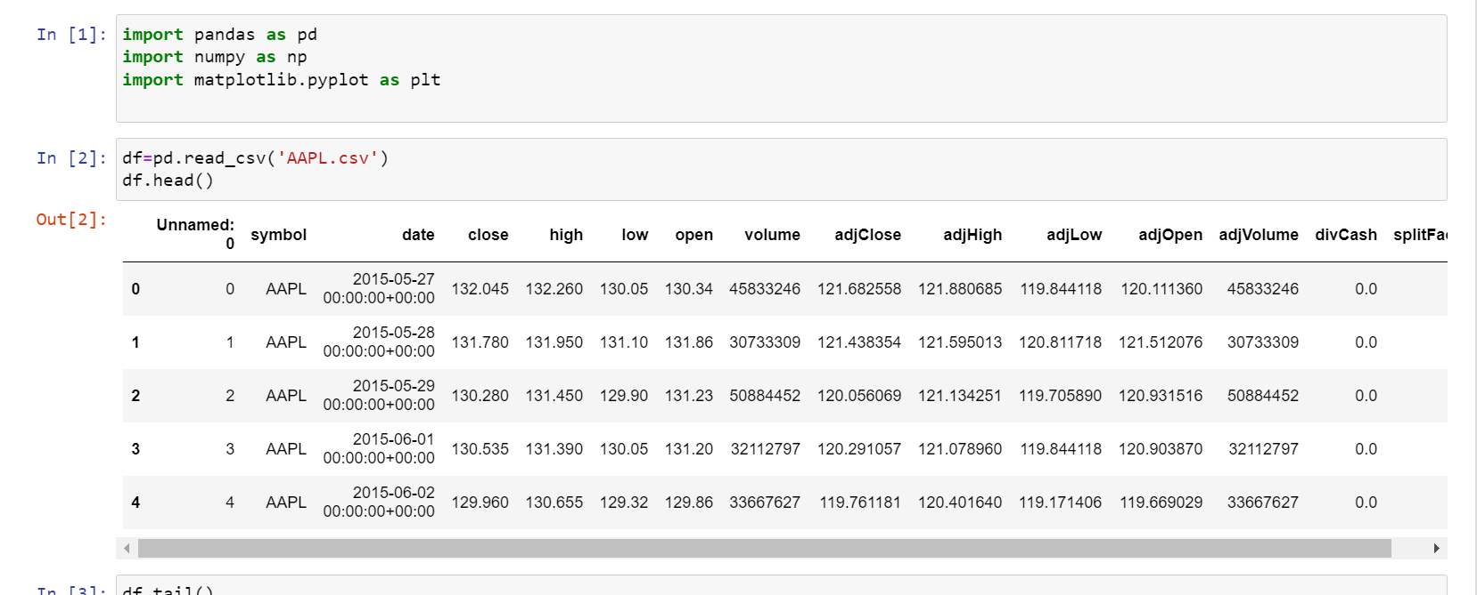

Importing basic libraries and checking the dataset

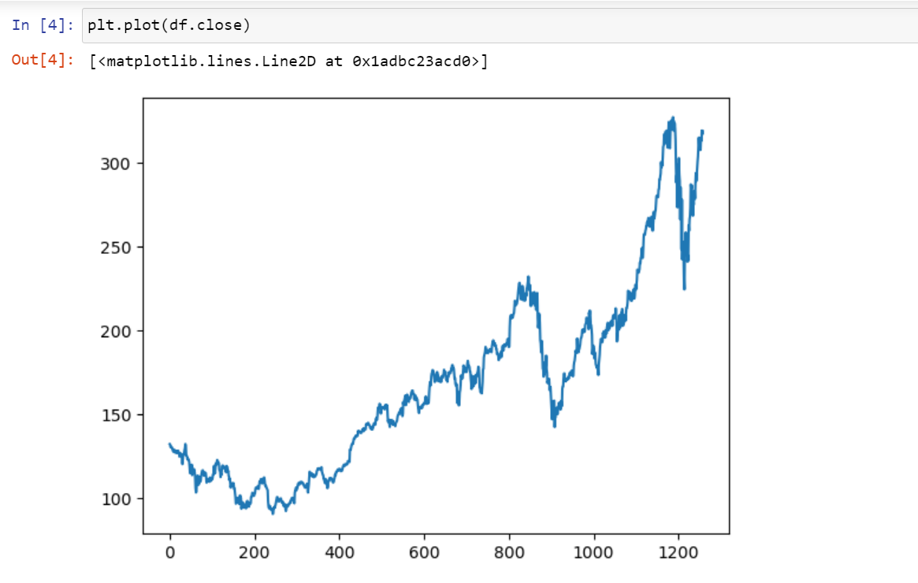

Plotting closing price as only this would be needed

Now in general conditions we use 100 days avg and 200 days avg to calculate if stock goes up or down

If 100 days>200 days avg then stock up else down

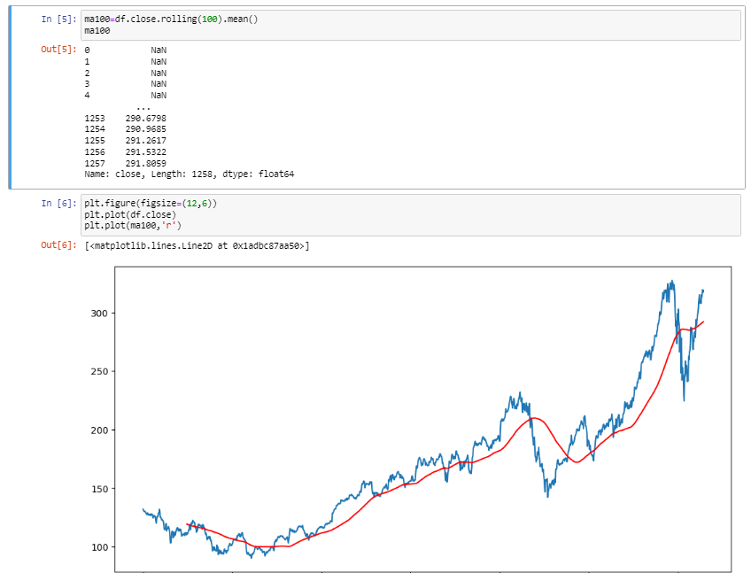

Calculated 100 days avg and plotted a graph

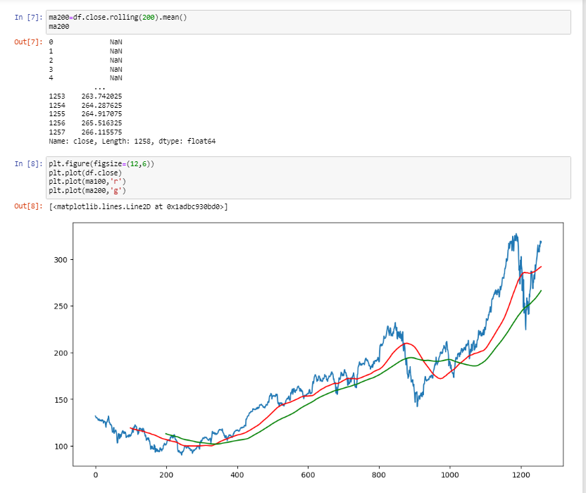

Calculated 200 days avg as well

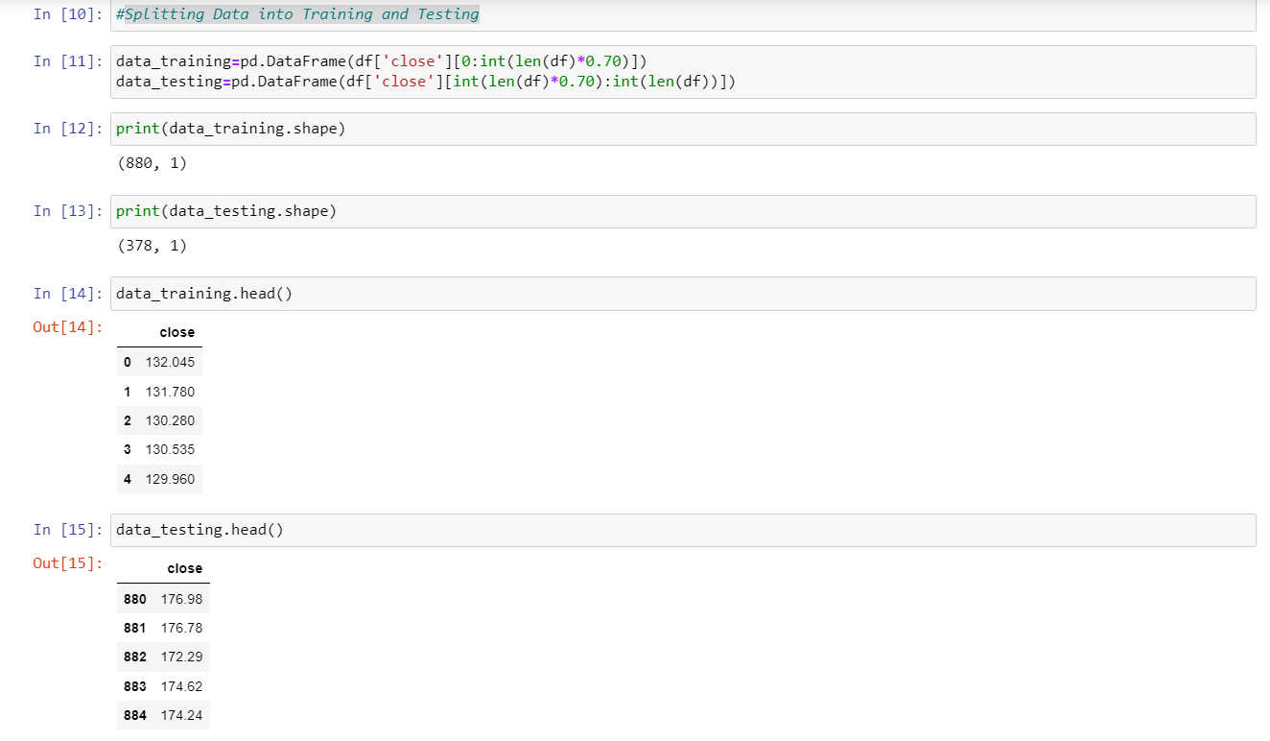

Splitting the data(70 perc training and 30 perc testing)

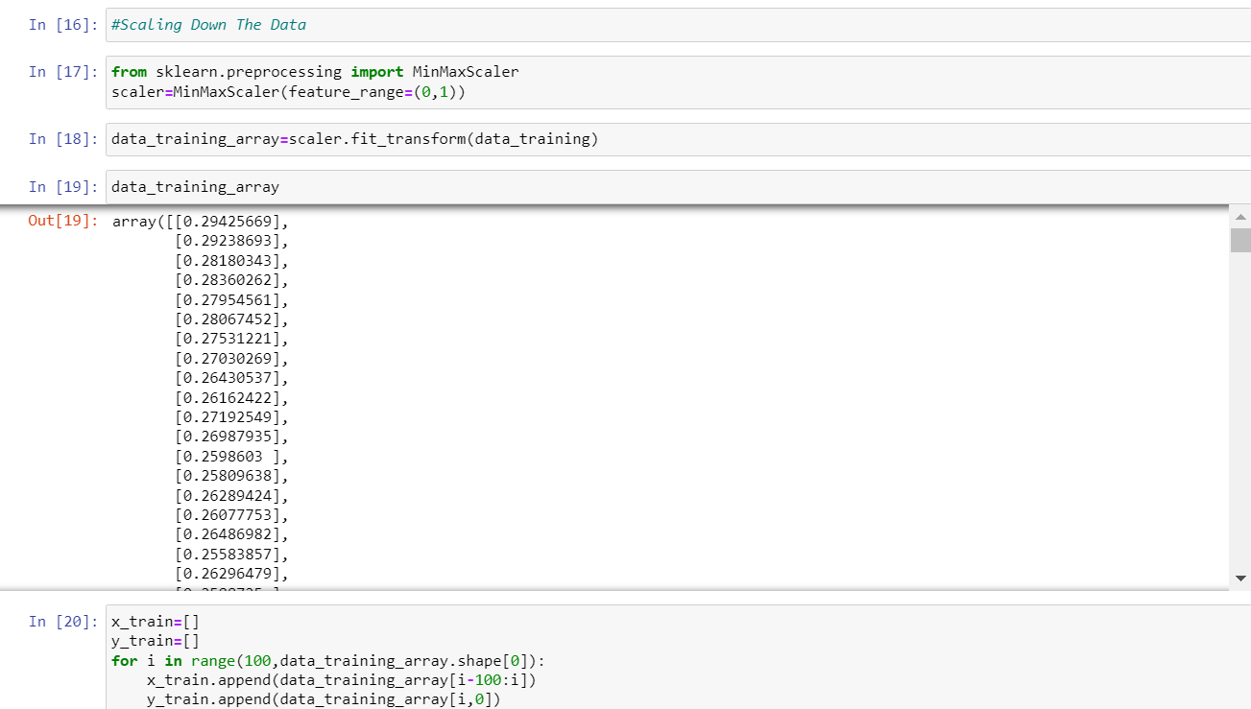

Scaled the data in between 0 to 1

Also made x train and y train which will be needed for prediction. we need the before 100 days for avg that is why there is a difference of 100 days

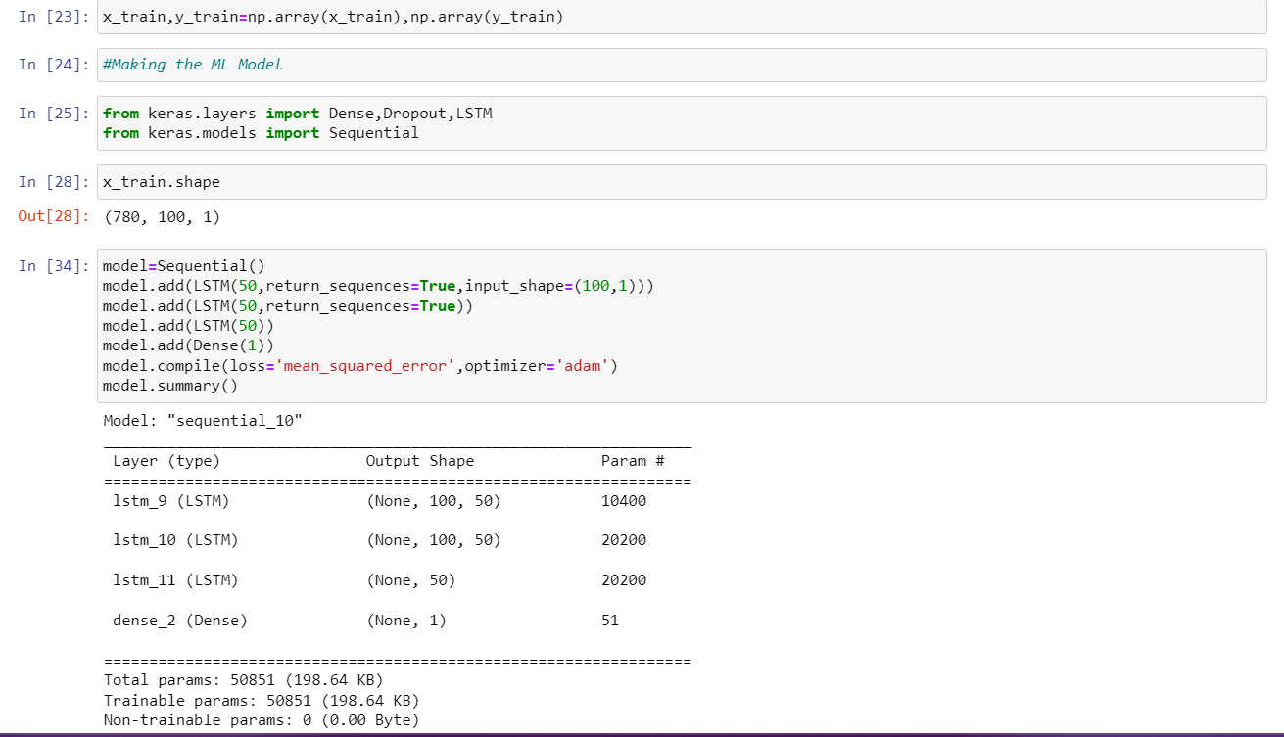

Made the ML Model with these specifications

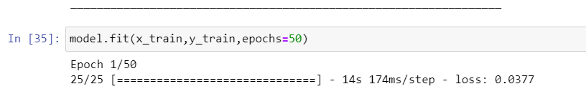

Ran 50 epochs

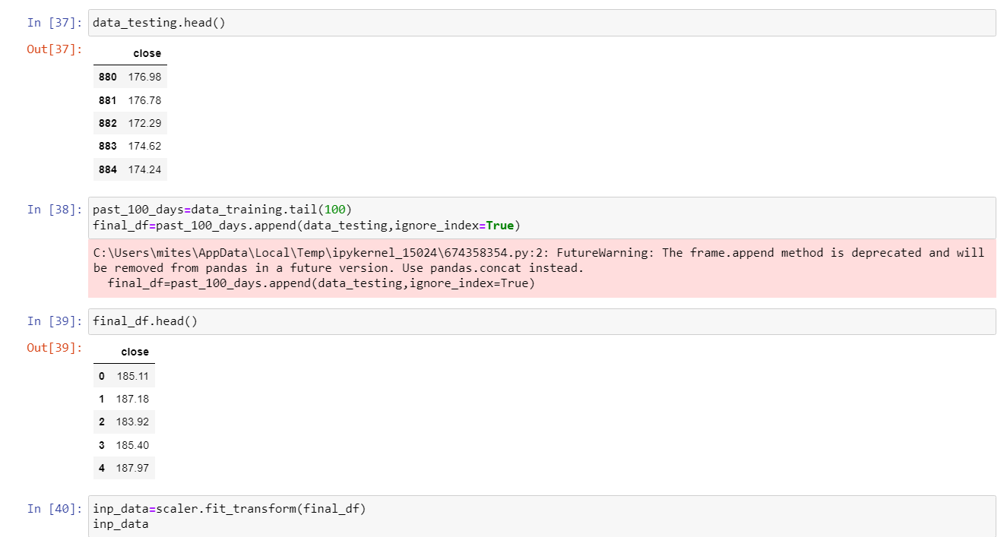

Scaled the testing data

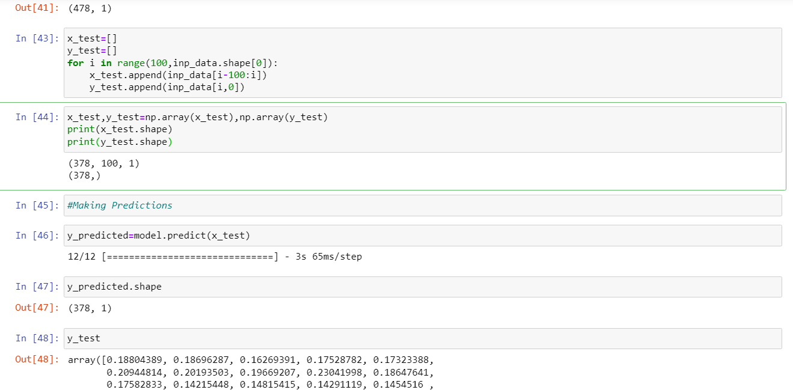

Same procedure and ran the model

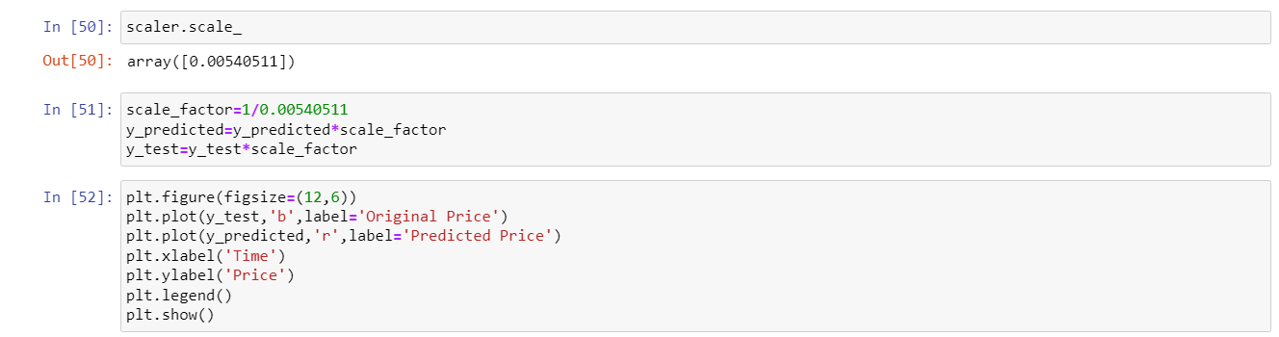

Now we will compare predicted values and actual values of testing data

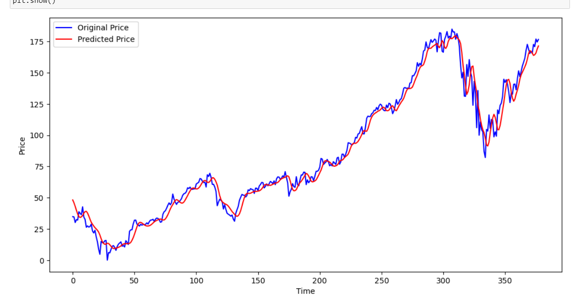

Final Prediction